**OEP** Remove duplicate lines from a large text or given document

import java.io.*;

class OEP

{

public static void main(String[] args) throws IOException

{

PrintWriter pw = new PrintWriter("output.txt");

BufferedReader br1 = new BufferedReader(new FileReader("input.txt"));

String line1 = br1.readLine();

while(line1 != null)

{

boolean flag = false;

BufferedReader br2 = new BufferedReader(new FileReader("output.txt"));

String line2 = br2.readLine();

while(line2 != null)

{

if(line1.equals(line2))

{

flag = true;

break;

}

line2 = br2.readLine();

}

if(!flag)

{

pw.println(line1);

pw.flush();

}

line1 = br1.readLine();

}

br1.close();

pw.close();

System.out.println("File operation performed successfully");

}

}

Output:

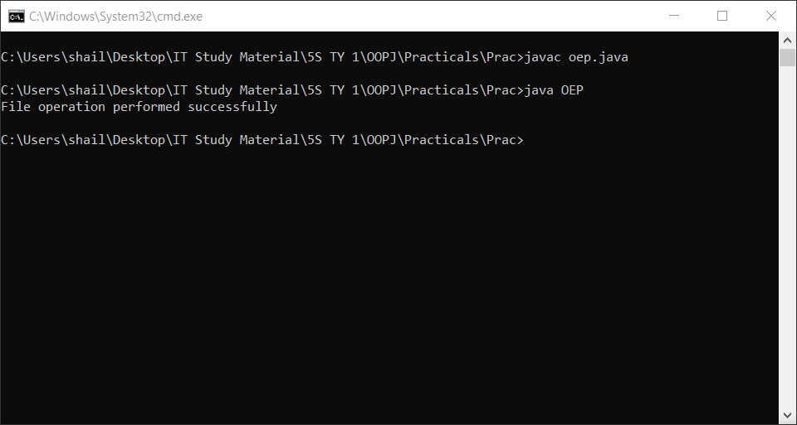

input.txt

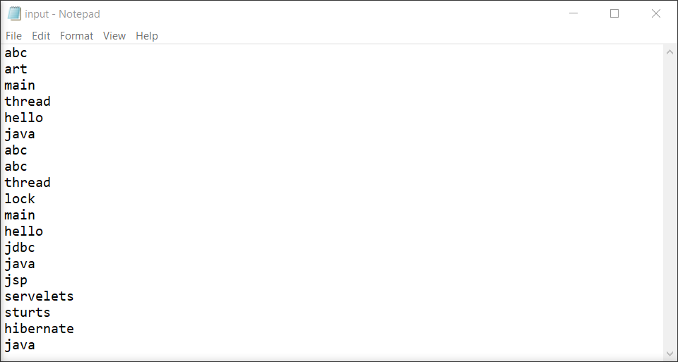

output.txt

